Project Title: Music Box One – Key Version
Link: https://wiki.microduino.cc/index.php/Music_Box_One%E2%80%94Key_Version


ORIGINAL:
Here we build a music box. By a crash switch, you can play, pause and cut music.
EDIT:
This tutorial will show you how to set up a music box that can be controlled using a pair of switches.

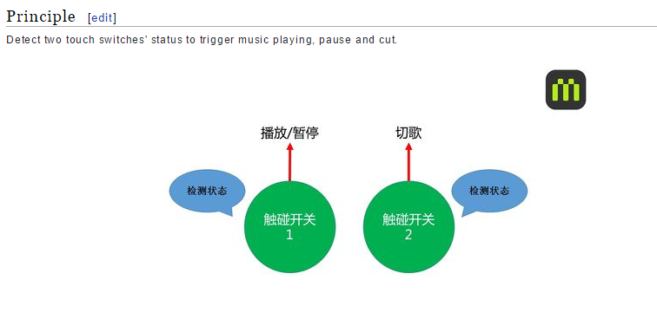
ORIGINAL:
Detect two touch switches’ status to trigger music playing, pause and cut.
EDIT:
The system built here will play and pause songs using the output from one switch, and skips songs using the output from another switch.
NOTE: THERE NEEDS TO BE TRANSLATED INFORMATION ON THE GRAPHICS ABOVE.

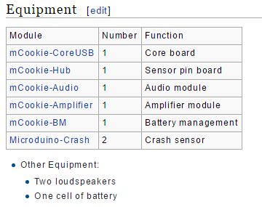

ORIGINAL:
- Other Equipment:
  - Two loudspeakers
  - At least one Lithium Ion 10440 Battery
  - A microSD card (for storing music)

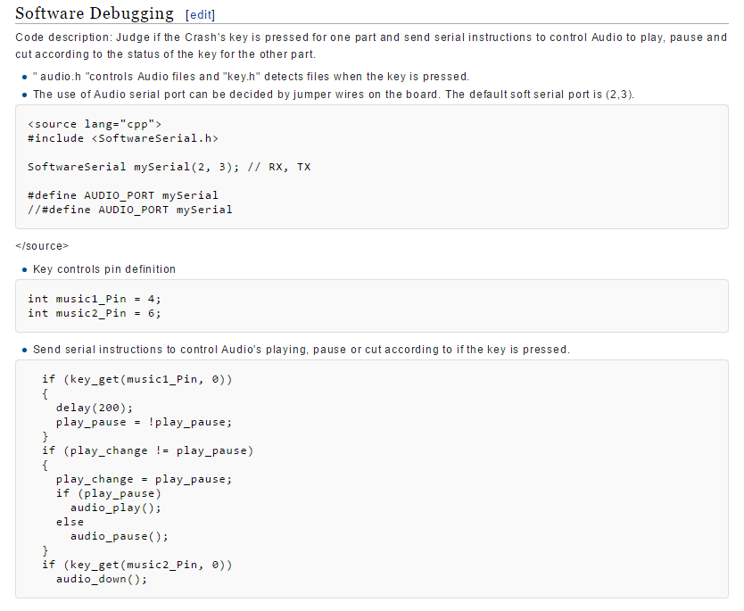

ORIGINAL:
Code description: Judge if the Crash's key is pressed for one part and send serial instructions to control Audio to play, pause and cut according to the status of the key for the other part.

EDIT:
Code Description:
The software will check the state of each switch. If the first switch is triggered the music will switch from playing to pause, depending on whether or not anything is currently playing. If the second switch is triggered, the next song in the queue will play if there is more than one song stored in memory.

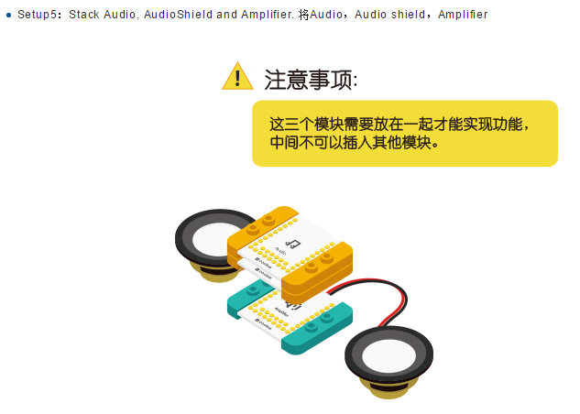

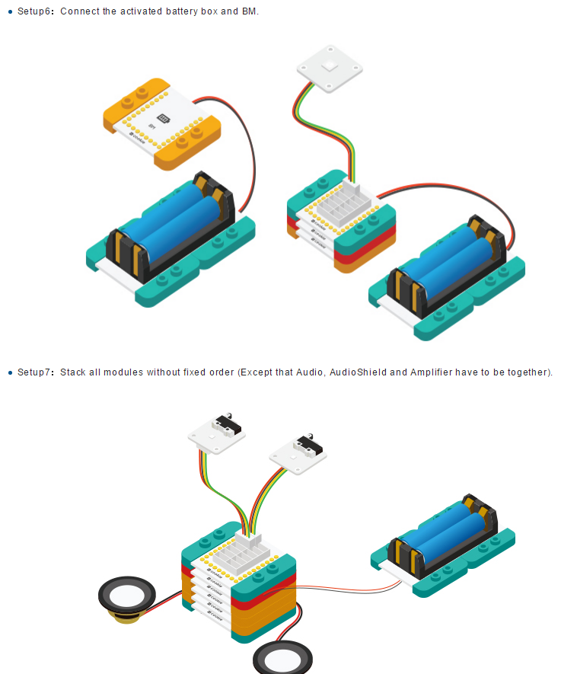

ORIGINAL:
Choosing to play, pause and cut songs via the crash switch. You can also build a beautiful shell for your project with LEGO since mCookie can be easily stacked with LEGO.
EDIT:
You can now play, pause and skip songs using just a pair of switches. You can also build a beautiful music box for your project using LEGO since mCookie is designed to be easily connected to LEGO pieces.

